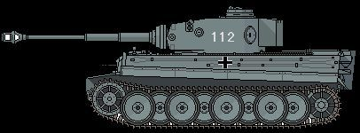
Figure 1Panzer leher
10th SS Pz
+2

